1. * 1. **Comparison of single and batch arrivals**

This subsection compares the single-arrival scenario with batch-arrival scenario at node 1. In the batch-arrival scenario, we set to be twice of , and the HP packet arrival rate is . In the single-arrival scenario, we set , and the HP packet arrival rate is . For a fair comparison, we set in both scenarios to be the same. The LP packet arrivals follow the same pattern as the HP packets. Subsequently, the results are shown in Fig. 5-60 to Fig. 5-80.

In Fig. 5-60, the relationship between the expected number of all packets in the network and each node (-, -, -, -) and the HP packet arrival rate is depicted. It is evident that the curves for batch arrival in - and - are higher than the curves for single arrival first and then they cross over. The distance between the curve for batch arrival and that for single arrival in - increases with the increase of initially, and then closes to in heavy load. In addition, the traffic at node 3 is considerably lower compared to the other nodes due to the routing probability. As a result, a majority of the arrived packets at node 3 can be promptly served, leading to minimal changes in - as increases whether it is a batch arrival or a single arrival.

In Fig. 5-61, the relationship between the expected number of HP and LP packets in the network and each node and the HP packet arrival rate is depicted. It is evident that the curves for batch arrival in - and - are always higher than the curves for single arrival. The curves for batch arrival and single arrival in - increase similarly as increase. Additionally, it is evident that the curves for batch arrival and single arrival in - undergo minimal changes and remain at near-zero. Furthermore, the curves for batch arrival in - and - are higher than the curves for single arrival first and then they cross over. The distance between the curve for batch arrival and that for single arrival in - increases with the increase of initially, and then closes to in heavy load.

In Fig. 5-62, the relationship between the expected number of all packets in queue for the network and each node (-, -, -, -) and the HP packet arrival rate is depicted. It is observed that both - and - gradually increase as increases. It is evident that the curves for batch arrival in - and - are higher than the curves for single arrival first and then they cross over. The distance between the curve for batch arrival and that for single arrival in - increases with the increase of initially, and then closes to in heavy load. In addition, the traffic at node 3 is considerably lower compared to the other nodes due to the routing probability. As a result, a majority of the arrived packets at node 3 can be promptly served, leading to minimal changes in - as increases whether it is a batch arrival or a single arrival.

In Fig. 5-63, the relationship between the expected number of HP and LP packets in queue for the network and each node and the HP packet arrival rate is depicted. It is evident that the curves for batch arrival in - and - are always higher than the curves for single arrival. The curves for batch arrival and single arrival in - increase similarly as increase. Additionally, it is evident that the curves for batch arrival and single arrival in - undergo minimal changes and remain at near-zero. Furthermore, the curves for batch arrival in - and - are higher than the curves for single arrival first and then they cross over. The distance between the curve for batch arrival and that for single arrival in - increases with the increase of initially, and then closes to in heavy load.

In Fig. 5-64, the relationship between the mean waiting time of all packets in the network and each node (-, -, -, -) and the HP packet arrival rate is depicted. It is evident that the curves for batch arrival in - and - are higher than the curves for single arrival first and then they cross over. The distance between the curve for batch arrival and that for single arrival in - increases with the increase of initially, and then closes to in heavy load. In addition, the traffic at node 3 is considerably lower compared to the other nodes due to the routing probability. As a result, a majority of the arrived packets at node 3 can be promptly served, leading to minimal changes in - as increases whether it is a batch arrival or a single arrival.

In Fig. 5-65, the relationship between the mean waiting time of HP and LP packets in the network and each node and the HP packet arrival rate is depicted. It is evident that the curves for batch arrival in - and - are always higher than the curves for single arrival. The curves for batch arrival and single arrival in - increase similarly as increase. Additionally, it is evident that the curves for batch arrival and single arrival in - undergo minimal changes and remain at near-zero. Furthermore, the curves for batch arrival in - and - are higher than the curves for single arrival first and then they cross over. The distance between the curve for batch arrival and that for single arrival in - increases with the increase of initially, and then gets closer in heavy load.

In Fig. 5-66, the relationship between the expected number of all packets in queue for the network and each node (-, -, -, -) and the HP packet arrival rate is depicted. It is observed that both - and - gradually increase as increases. It is evident that the curves for batch arrival in - and - are higher than the curves for single arrival first and then they cross over. The distance between the curve for batch arrival and that for single arrival in - increases with the increase of initially, and then closes to in heavy load. In addition, the traffic at node 3 is considerably lower compared to the other nodes due to the routing probability. As a result, a majority of the arrived packets at node 3 can be promptly served, leading to minimal changes in - as increases whether it is a batch arrival or a single arrival.

In Fig. 5-67, the relationship between the expected number of HP and LP packets in queue for the network and each node and the HP packet arrival rate is depicted. It is evident that the curves for batch arrival in - and - are always higher than the curves for single arrival. The curves for batch arrival and single arrival in - increase similarly as increase. Additionally, it is evident that the curves for batch arrival and single arrival in - undergo minimal changes and remain at near-zero. Furthermore, the curves for batch arrival in - and - are higher than the curves for single arrival first and then they cross over. The distance between the curve for batch arrival and that for single arrival in - increases with the increase of initially, and then gets closer in heavy load.

In Fig. 5-68, the relationship between the throughput of all packets in queue for the network and each node (-, -, -, -) and the HP packet arrival rate is depicted. It is observed that the curves for batch arrival in -, -, and - are lower than the curves for single arrival, and get closer in heavy load. In addition, the curves for either batch arrival or single arrival in - are the same as increase.

In Fig. 5-69, the relationship between the throughput of HP and LP packets in queue for the network and each node and the HP packet arrival rate is depicted. It is evident that the curves for batch arrival in -, -, and - are always lower than the curves for single arrival. The curves for batch arrival and single arrival in - increase similarly as increase. Additionally, the curves for batch arrival in -, -, and - are initially lower than the curves for single arrival and then become the same. The curves for batch arrival and single arrival in - decrease similarly as increase.

In Fig. 5-70, the relationship between the energy loss probability and the HP packet arrival rate is depicted. No matter if it is single arrival or batch arrival, it is observed that - and - remains consistently at zero. In addition, it is evident that as increases, the curve for batch arrival in - is initially lower than the curves for single arrival and then become the same. Consequently, the curves for batch arrival and single arrival in - decrease similarly as increase.

In Fig. 5-71, the relationship between the blocking probabilities for all arrived packets of the network and each node (-, - -, and -) and the HP packet arrival rate is depicted. It is observed that the curves for batch arrival in - and - are higher than that for single arrival, and the distances between them get closer in heavy load. The distance between the curve for batch arrival and that for single arrival in - increases with the increase of initially, and then closes to in heavy load. In addition, the traffic at node 3 is considerably lower compared to the other nodes due to the routing probability. As a result, it is evident that the curve in - remains consistently at zero.

In Fig. 5-72, the relationship between the blocking probabilities for arrived HP and LP packets of the network and each node and the HP packet arrival rate is depicted. It is observed that the curves for batch arrival in - (-) and - (-) are initially higher than those for single arrival, and then gets closer in heavy load. In addition, the distance between the curves for batch arrival and that for single arrival in - (-) increase as increase. Consequently, no matter if it is single arrival or batch arrival, it is evident that the curve in - (-) remains consistently at zero.

In Fig. 5-73, the relationship between the total loss probabilities for all arrived packets of the network and each node (-, - -, and -) and the HP packet arrival rate is depicted. It is observed that the curves for batch arrival in - and - are higher than that for single arrival, and the distances between them get closer in heavy load. The distance between the curve for batch arrival and that for single arrival in - increases with the increase of initially, and then closes to in heavy load. In addition, the traffic at node 3 is considerably lower compared to the other nodes due to the routing probability. As a result, it is evident that the curve in - remains consistently at zero.

In Fig. 5-74, the relationship between the total loss probabilities for arrived HP and LP packets of the network and each node and the HP packet arrival rate is depicted. It is observed that the curves for batch arrival in - and - are always higher than those for single arrival. In addition, the curve for batch arrival in - is always lower than those for single arrival. Consequently, the curves for batch arrival in -, -, and - are higher than the curves for single arrival first and then they cross over. Consequently, no matter if it is single arrival or batch arrival, it is evident that the curve in - (-) remains consistently at zero.

In Fig. 5-75, the relationship between the impatient loss probability for all arrived packets of the network and each node (-, - -, and -) and the HP packet arrival rate is depicted. It is evident that the curves for batch arrival in - and - are higher than the curves for single arrival first and then they cross over. The distance between the curve for batch arrival and that for single arrival in - increases with the increase of initially, and then closes to in heavy load. In addition, the traffic at node 3 is considerably lower compared to the other nodes due to the routing probability. As a result, it is evident that the curves for batch arrival and single arrival in - undergo minimal changes and remain at near-zero.

In Fig. 5-76, the relationship between the impatient loss probabilities for arrived HP and LP packets of the network and each node and the HP packet arrival rate is depicted. It is evident that the curves for batch arrival in -, - and - are always higher than the curves for single arrival. Additionally, the curves for batch arrival in - and - are higher than the curves for single arrival first and then they cross over. Furthermore, the curve for batch arrival in - is lower than the curve for single arrival. In addition, the traffic at node 3 is considerably lower compared to the other nodes due to the routing probability. As a result, it is evident that the curves for batch arrival and single arrival in - and - undergo minimal changes and remain at near-zero.

In Fig. 5-77, the relationship between the impatient loss probabilities for all admitted packets of the network and each node (-, - -, and -) and the HP packet arrival rate is depicted. It is evident that the curves for batch arrival in - and - are higher than the curves for single arrival first and then they cross over. The distance between the curve for batch arrival and that for single arrival in - increases with the increase of initially, and then closes to in heavy load. In addition, the traffic at node 3 is considerably lower compared to the other nodes due to the routing probability. As a result, it is evident that the curves for batch arrival and single arrival in - undergo minimal changes and remain at near-zero.

In Fig. 5-78, the relationship between the impatient loss probabilities for admitted HP and LP packets of the network and each node and the HP packet arrival rate is depicted. It is evident that the curves for batch arrival in - and - are always higher than the curves for single arrival. Consequently, the curves for either batch arrival or single arrival in - is the same as increase. Additionally, the curves for batch arrival in - and - are higher than the curves for single arrival first and then they cross over. Furthermore, the curve for batch arrival in - is lower than the curve for single arrival. In addition, the traffic at node 3 is considerably lower compared to the other nodes due to the routing probability. As a result, it is evident that the curves for batch arrival and single arrival in - and - undergo minimal changes and remain at near-zero.

In Fig. 5-79, the relationship between the regular energy consumption ratio for serving all packets of the network and each node (-, -, -, and -) and the HP packet arrival rate is depicted. It is observed that the curves for batch arrival in -, -, and - are lower than the curves for single arrival, and get closer in heavy load. In addition, the traffic at node 3 is considerably lower compared to the other nodes due to the routing probability. As a result, the energy from harvesting energy is sufficient causing the curve in - remains consistently at zero.

In Fig. 5-80, the relationship between the regular energy consumption ratio for serving HP and LP packets of the network and each node and the HP packet arrival rate is depicted. It is observed that the curves for batch arrival in - and -*n*, *n*=1, 2 are lower than those of single arrival. Consequently, the curves for batch arrival in - (-*n*, *n*=1, 2) are lower than the curves for single arrival, and get closer in heavy load. Furthermore, the traffic at node 3 is considerably lower compared to the other nodes due to the routing probability. As a result, the energy from harvesting energy is sufficient causing the curve in - and - remains consistently at zero.

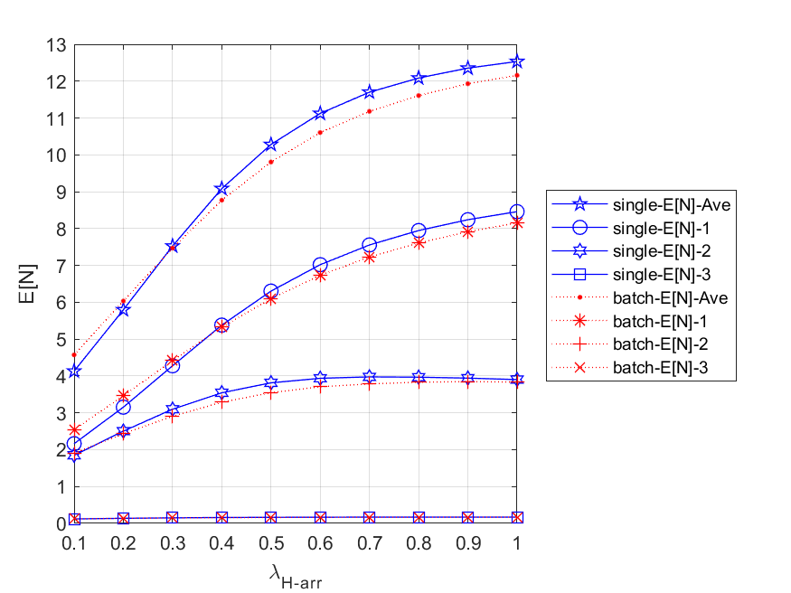

Fig. 5 - 60: The expected number of all packets in the network and each node vs. the HP packet arrival rate for single and batch arrival

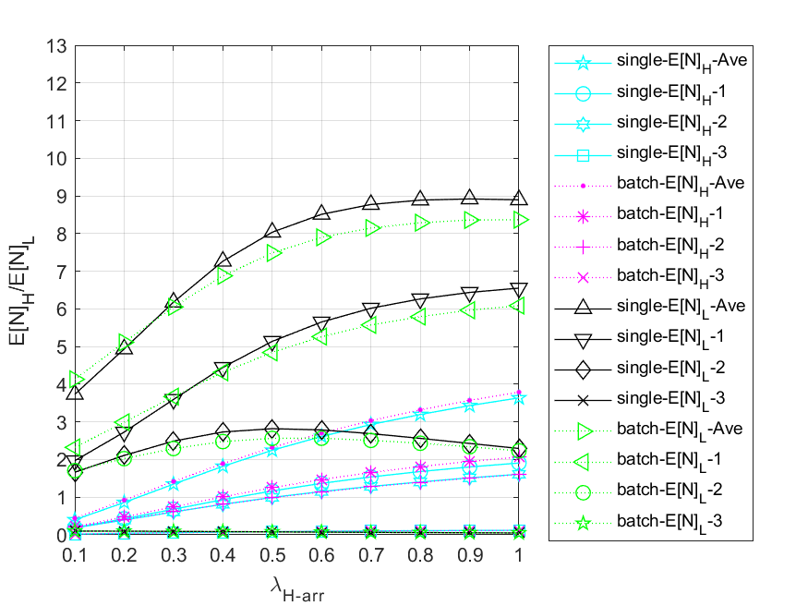

Fig. 5 - 61: The expected number of HP and LP packets in the network and each node vs. the HP packet arrival rate for single and batch arrival

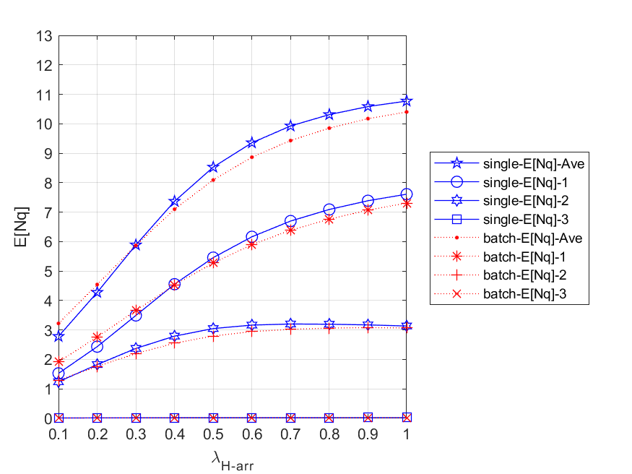

Fig. 5 - 62: The expected number of all packets in queue for the network and each node vs. the HP packet arrival rate for single and batch arrivals

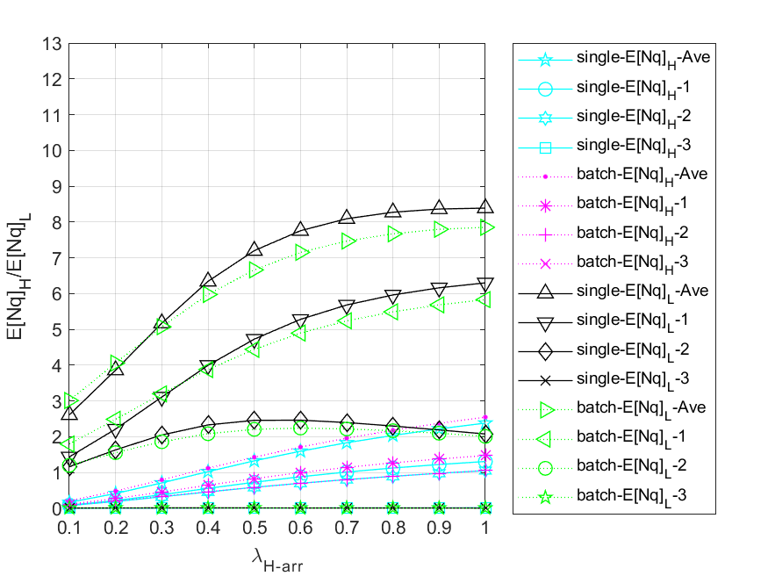

Fig. 5 - 63: The expected number of HP and LP packets in queue for the network and each node vs. the HP packet arrival rate for single and batch arrivals

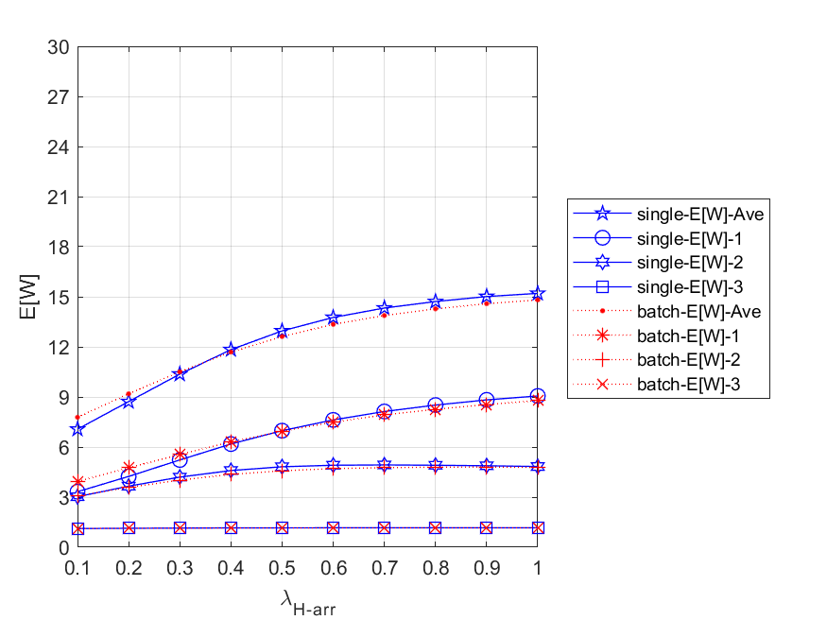

Fig. 5 - 64: The mean waiting time of all packets in queue for the network and each node vs. the HP packet arrival rate for single and batch arrival

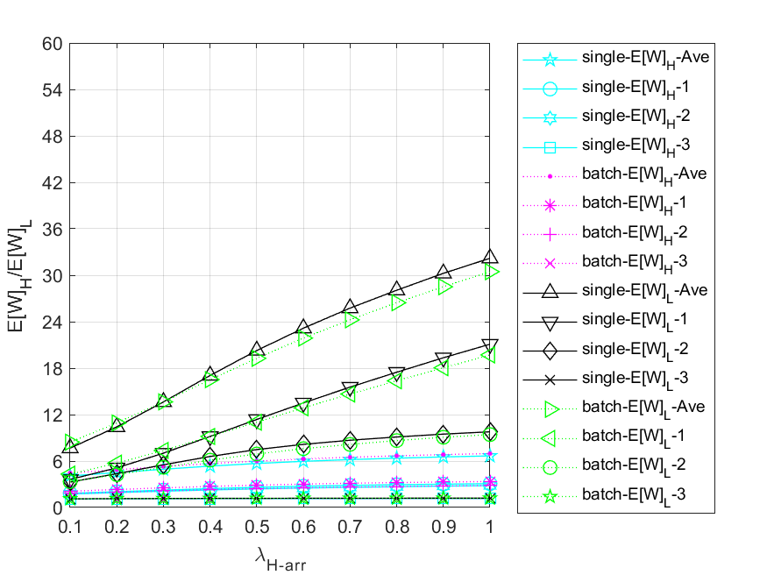

Fig. 5 - 65: The mean waiting time of HP and LP packets in queue for the network and each node vs. the HP packet arrival rate for single and batch arrival

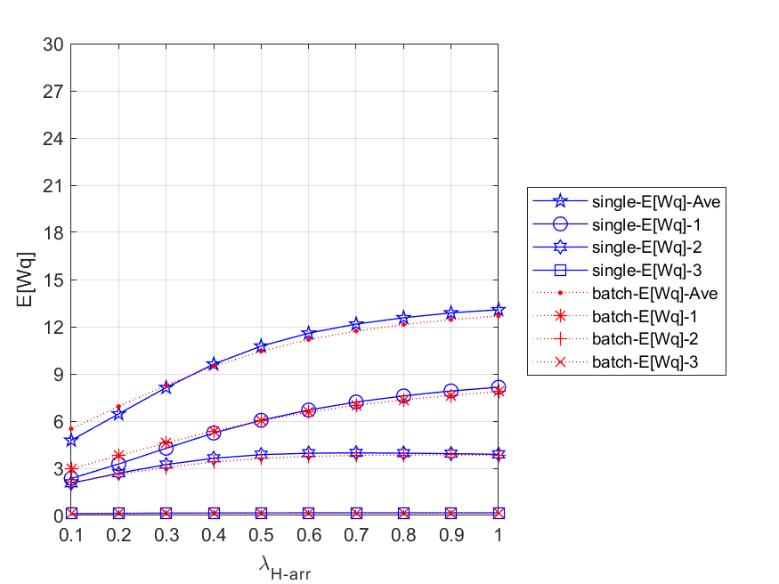

Fig. 5 - 66: The mean waiting time of all packets in queue for the network and each node vs. the HP packet arrival rate for single and batch arrival

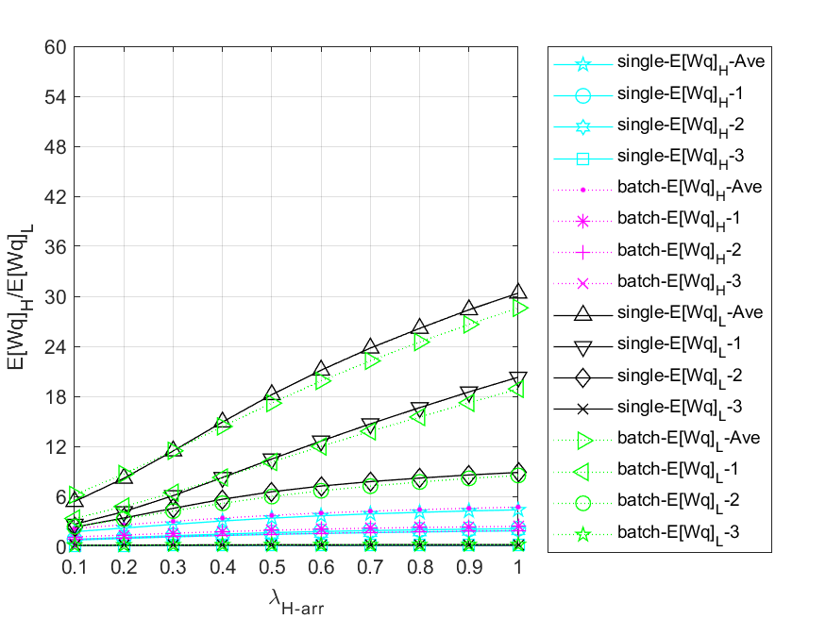

Fig. 5 - 67: The mean waiting time of HP and LP packets in queue for the network and each node vs. the HP packet arrival rate for single and batch arrival

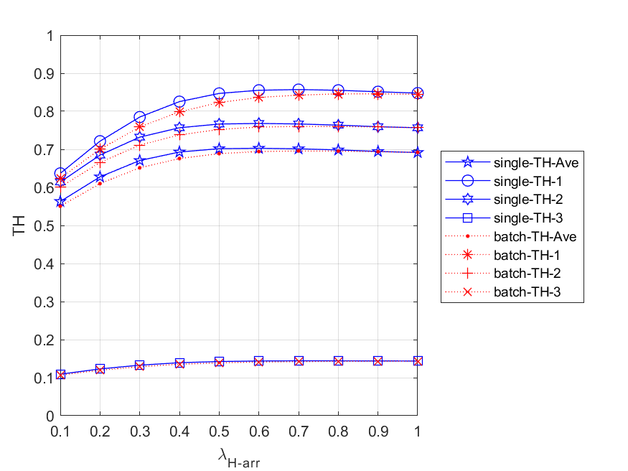

Fig. 5 - 68: The throughput of all packets in queue for the network and each node vs. the HP packet arrival rate for single and batch arrival

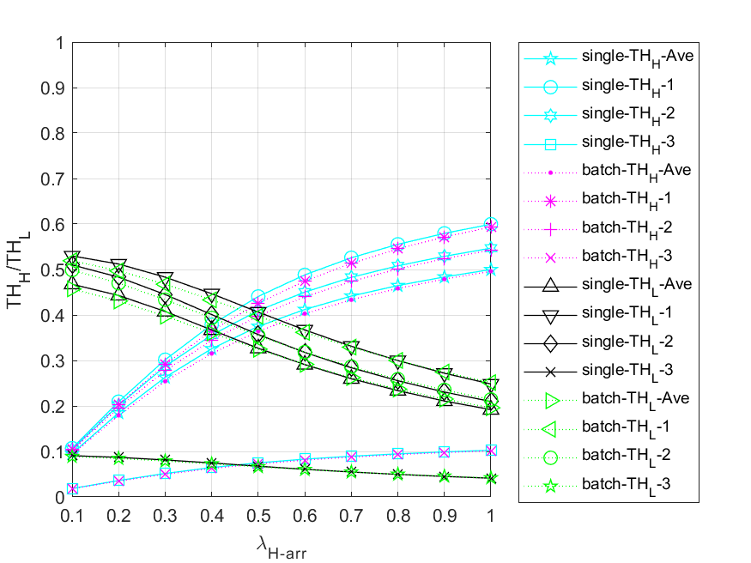

Fig. 5 - 69: The throughput of HP and LP packets in queue for the network and each node vs. the HP packet arrival rate for single and batch arrival

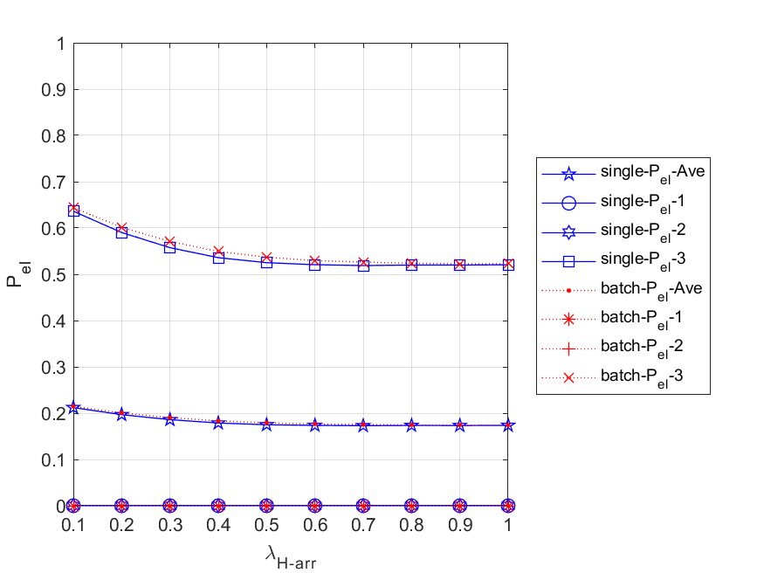

Fig. 5 - 70: The energy loss probability vs. the HP packet arrival rate for single and batch arrival

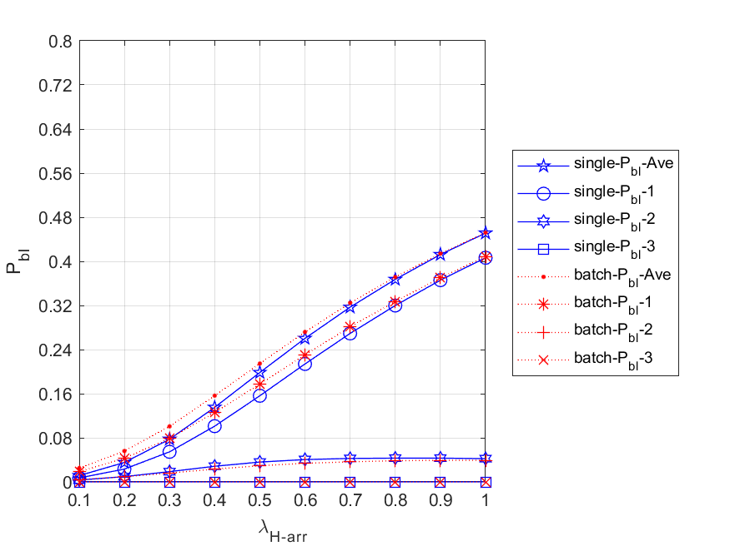

Fig. 5 - 71: The blocking probability of all packets for the network and each node vs. the HP packet arrival rate for single and batch arrival

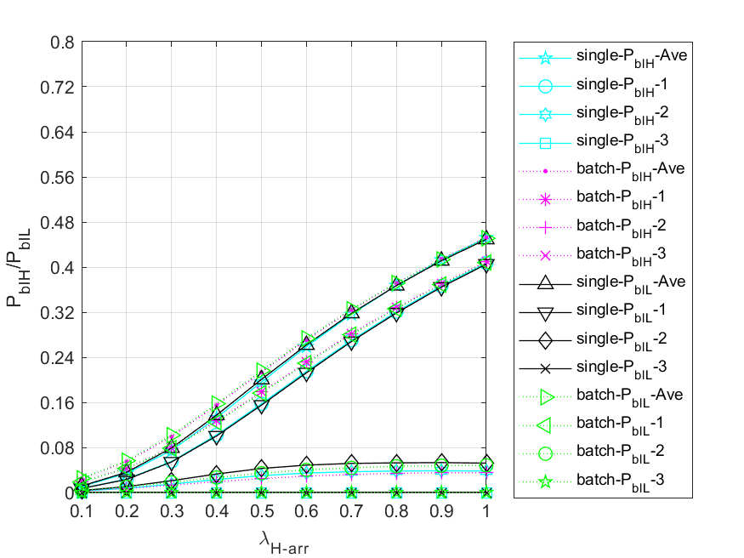

Fig. 5 - 72: The blocking probability of HP and LP packets for the network and each node vs. the HP packet arrival rate for single and batch arrival

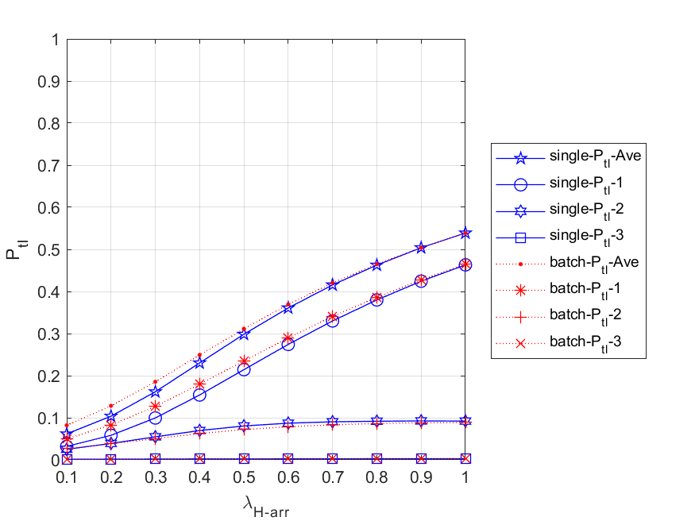

Fig. 5 - 73: The total loss probability of all packets for the network and each node vs. the HP packet arrival rate for single and batch arrival

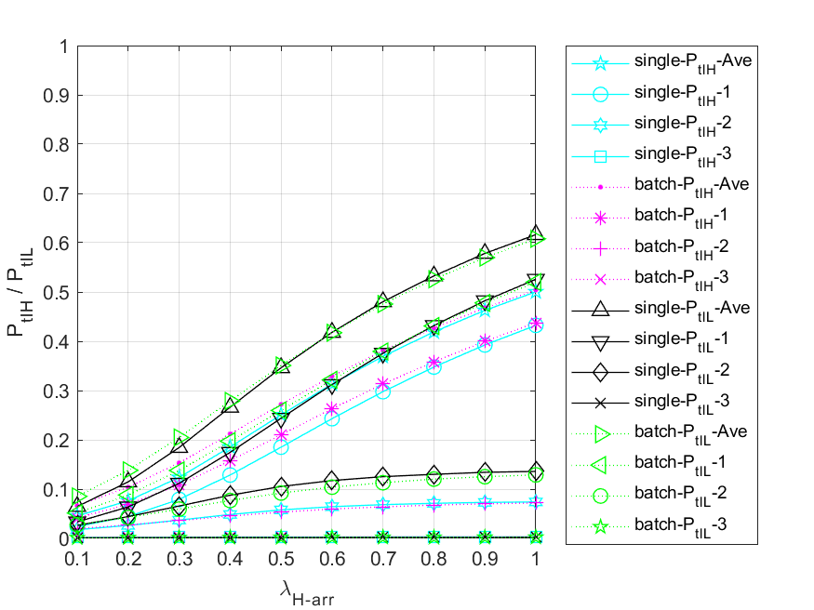

Fig. 5 - 74: The total loss probability of HP and LP packets for the network and each node vs. the HP packet arrival rate for single and batch arrival

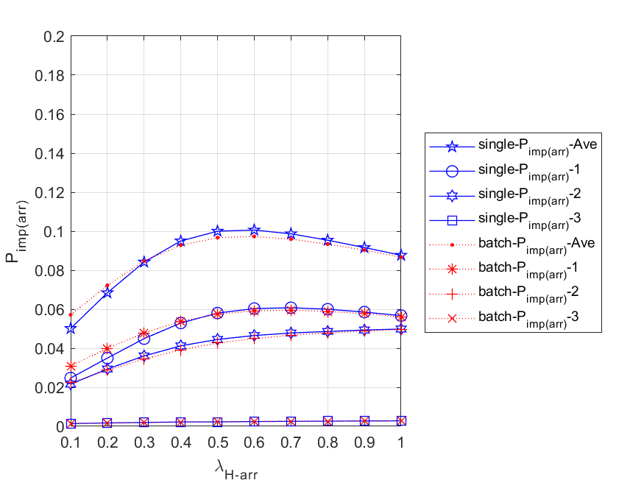

Fig. 5 - 75: The impatient loss probability of all packets for the network and each node vs. the HP packet arrival rate for single and batch arrival

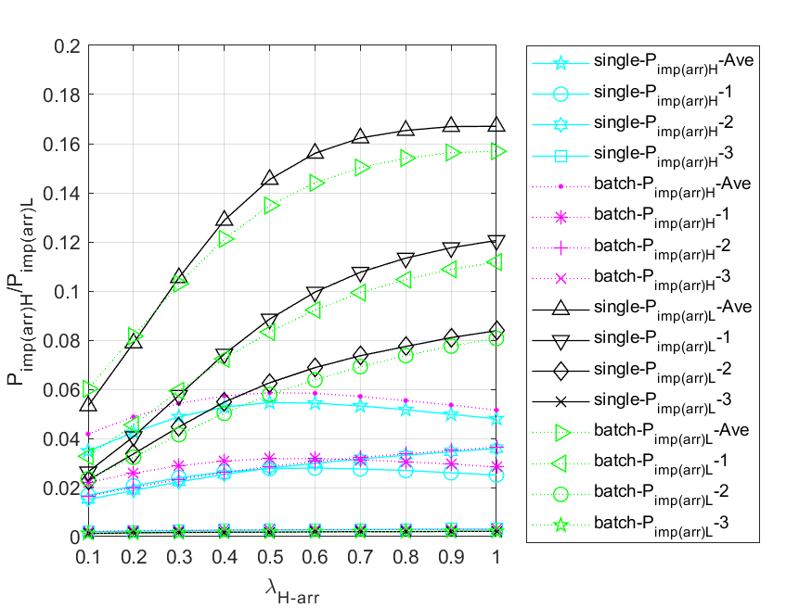

Fig. 5 - 76: The impatient loss probability of HP and LP packets for the network and each node vs. the HP packet arrival rate for single and batch arrival

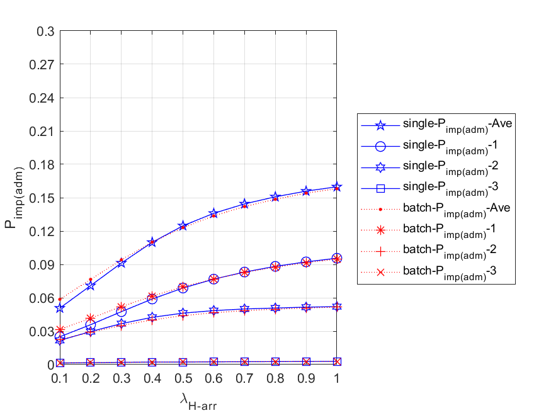

Fig. 5 - 77: The impatient loss probability of all packets for the network and each node vs. the HP packet arrival rate for single and batch arrival

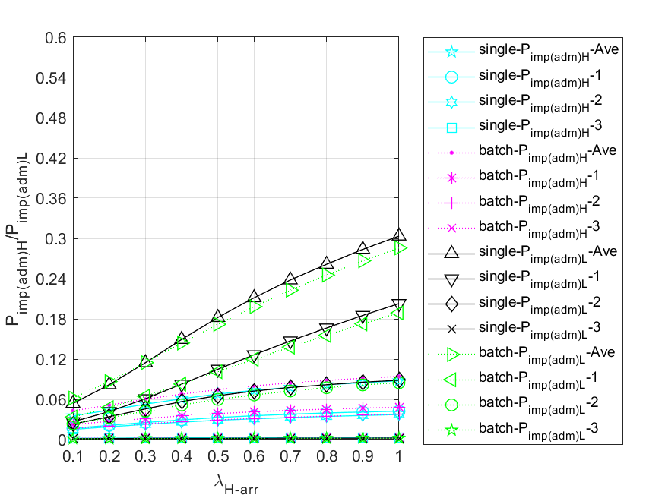

Fig. 5 - 78: The impatient loss probability of HP and LP packets for the network and each node vs. the HP packet arrival rate for single and batch arrival

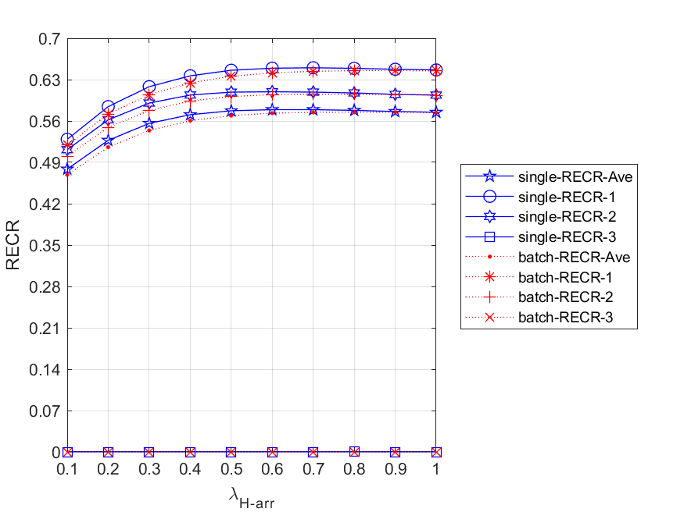

Fig. 5 - 79: The regular energy consumption ratio for serving all packets for the network and each node vs. the HP packet arrival rate for single and batch arrival

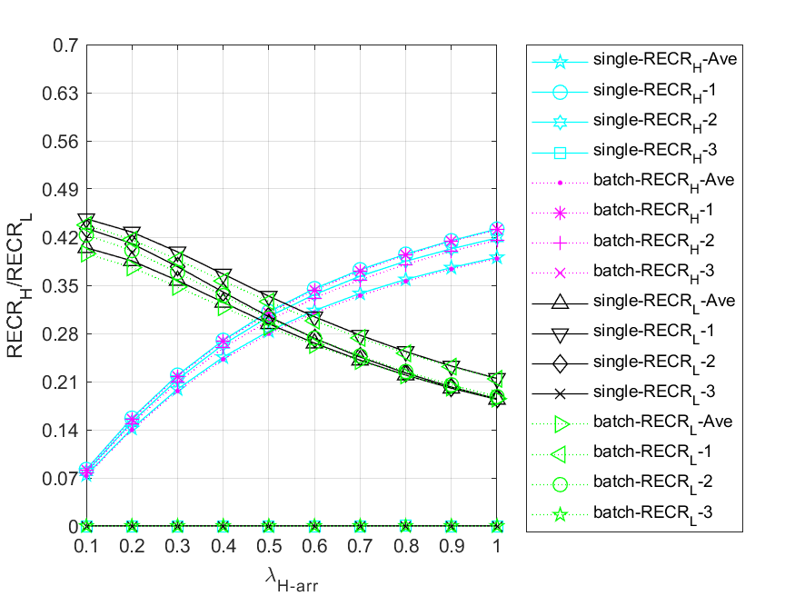

Fig. 5 - 80: The regular energy consumption ratio for serving HP and LP packets for the network and each node vs. the HP packet arrival rate for single and batch arrival